**TOPIC 15,16,17 Hands-On SQL**

**Kevin Avicenna Widiarto**

1. Identify the top 10 customers and their email so we can reward them

select concat(first_name,' ',last_name)as full_name,email,sum(amount) as total_amount_paid

from customer

inner join payment on payment.customer_id=customer.customer_id

group by 1,2

order by 3 desc

limit 10;

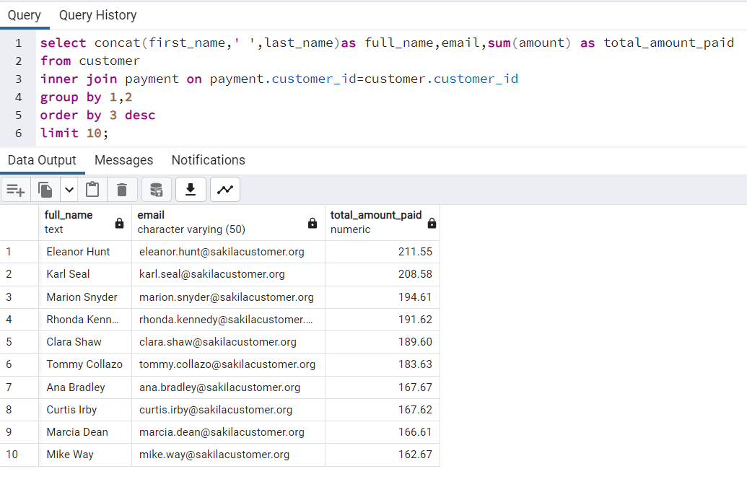

1. Identify the bottom 10 customers and their emails

select concat(first_name,' ',last_name)as full_name,email,sum(amount) as total_amount_paid

from customer

inner join payment on payment.customer_id=customer.customer_id

group by 1,2

order by 3 asc

limit 10;

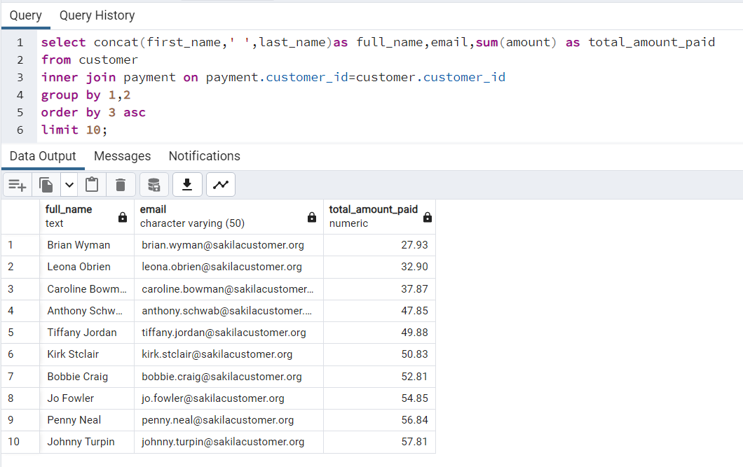

1. What are the most profitable movie genres (ratings)?

select category.name as genre,count(customer.customer_id) as total_demand,

sum(payment.amount) as total_sales from category

inner join film_category on category.category_id=film_category.category_id

inner join film on film_category.film_id=film.film_id

inner join inventory on film.film_id=inventory.film_id

inner join rental on inventory.inventory_id=rental.inventory_id

inner join customer on rental.customer_id=customer.customer_id

inner join payment on rental.rental_id=payment.rental_id

group by 1

order by 2 desc

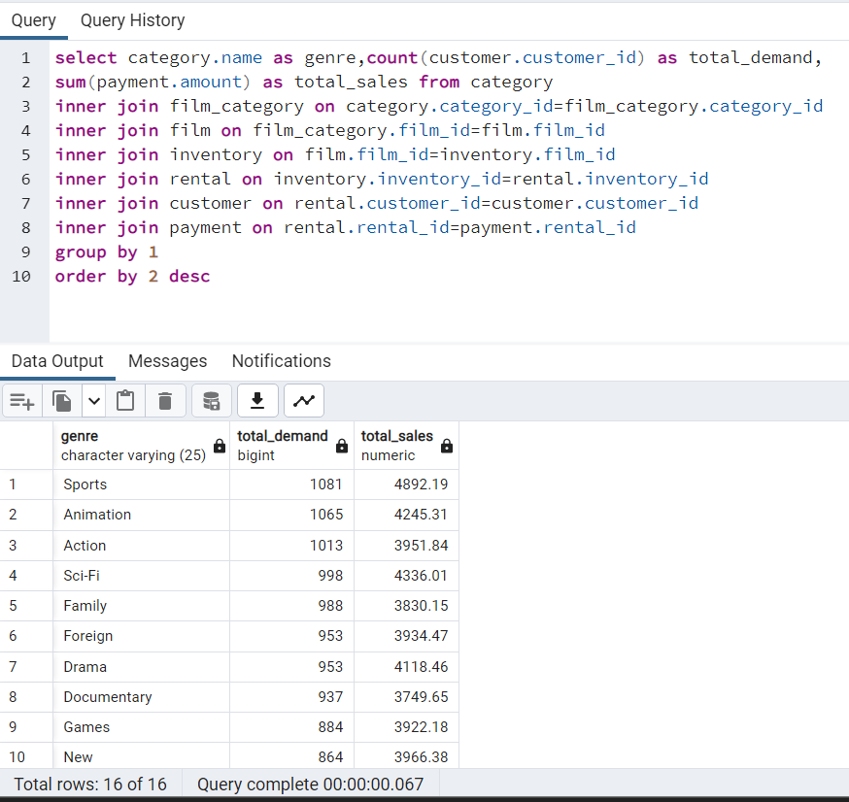

1. How many rented movies were returned late, early, and on time?

select case

when rental_duration > date_part('day',return_date-rental_date) then 'early'

when rental_duration = date_part('day',return_date-rental_date) then 'on time'

else 'late'

end as status_return,

count(*) as total_no_of_films

from film

inner join inventory on film.film_id=inventory.film_id

inner join rental on inventory.inventory_id = rental.inventory_id

group by 1 order by 2 desc

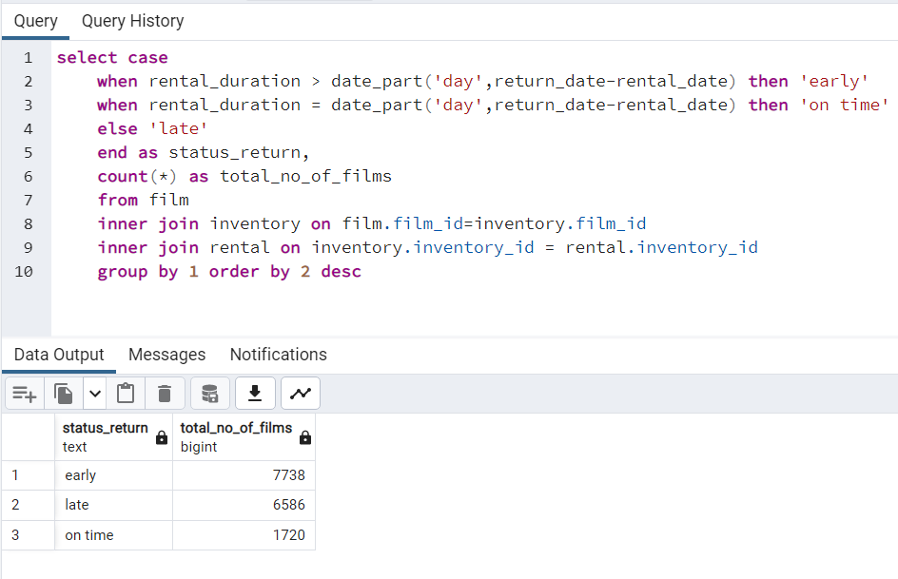

1. What is the customer base in the countries where we have a presence?

select country,count(customer_id)as customer

from country

inner join city on country.country_id=city.country_id

inner join address on city.city_id=address.city_id

inner join customer on address.address_id=customer.address_id

group by 1

order by 2 desc

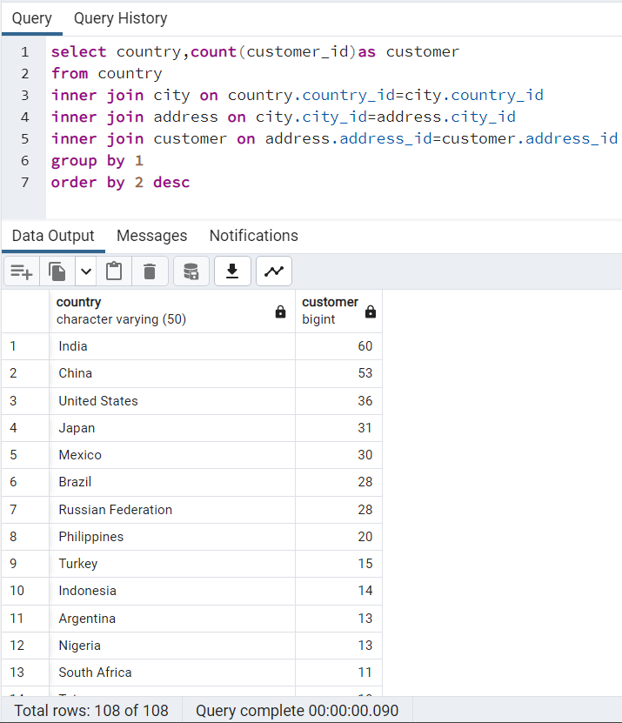

1. Which country is the most profitable for the business?

select country,count(*) as total_no_cust,sum(amount) as total_penjualan

from country

inner join city on country.country_id=city.country_id

inner join address on city.city_id=address.city_id

inner join customer on address.address_id=customer.address_id

inner join payment on customer.customer_id=payment.customer_id

group by 1

order by 2 desc

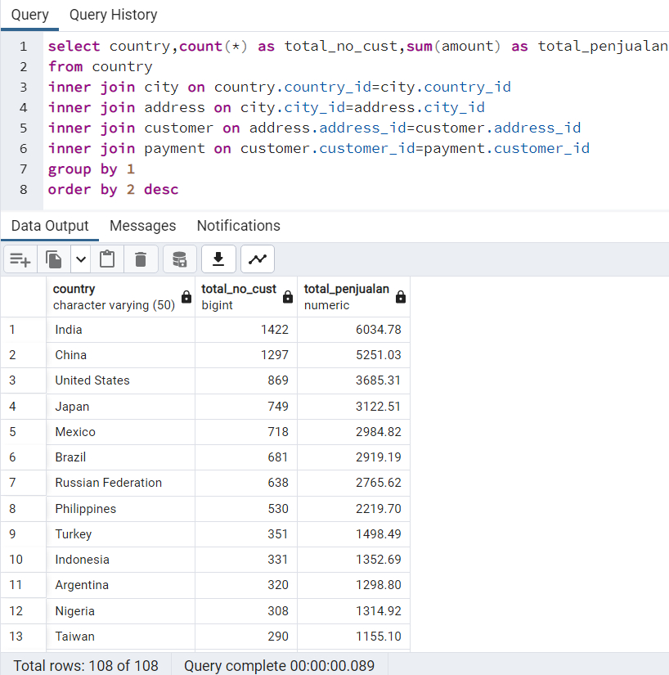

1. What is the average rental rate per movie genre (rating)?

select name as movie_genre,avg(rental_rate) as avg_rental_rate

from category

join film_category

using(category_id)

join film

using(film_id)

group by 1

order by 2 descs

